Georgia State Parks and Historic Sites
Weekend Summary
06.29.2020

Crowds:
- Several sites had severe weather this weekend. Elijah Clark had 6-8 trees down including one on a camper and three vehicles received damage from fallen limbs. There was no personal injury. Crooked River had a camper that sustained minor damage to the unit. Little Ocmulgee had approximately 15 trees down including one on the corner of a cottage roof and one on a park vehicle but no injuries. There was quite a bit of rain throughout the state which decreased day use visitation particularly on Saturday. Only four sites had to temporarily limit day use access Saturday including Cloudland, Tallulah Gorge, Tugaloo and Vogel. Sunday was busier and sites that had to temporarily limit day use access due to capacity include Cloudland Canyon, Ft. Yargo, Sweetwater, Tallulah Gorge, Tugaloo and Vogel.

- Golf Course activity continues to be high with this weekend 58% above last year, although the rising temperature is slowing afternoon play. Pro Water Sport event at Tugaloo was well attended and successful. Parks staff and LED assisted with social distance monitoring. The boat ramp at Fort McAllister was at or near capacity most of the weekend due to a fishing tournament.

Staffing issues:
- As of Monday, the Division has 26 part-time and full-time staff out due to COVID-19 related reasons. A total of 42 Camp Host Units (approximately 84 people) have left due to COVID-19 and 39 units have been replaced. A total of 22 employees have tested for COVID-19 and 2 were positive, 18 negative and 1 is awaiting results.
Positives
- Picnic and group shelter rentals are increasing.
- A GEMA training event was held at Cloudland Canyon.
- The cannon restoration at Fort Morris has been completed.
- Fort Yargo tested a new tablet in the kiosk to accept credit cards for day pass purchases. A separate report will be submitted on how it performed.
- Website Statistics for this past week continue to be high. The Alerts page had 14,322 pageviews and YTD is 489,776. Reservations pageviews were up 67% over last year and total Pageviews up 70%. YTD pageviews are 29,162,255 which is 56% over last year.
- Facebook stats also continue to be high with post engagement (people interacting with our posts by liking, reacting, commenting, or clicking links) at 7,406. Up 47% from the previous week. Instagram post reach (people who saw any of our posts) was 32,187 which was up 10% from last week.
- The Resource Management Unit has been working hard on invasive species including treating the endangered Carolina Hemlocks at Tallulah Gorge against the Hemlock Woolly Adelgid. Treatment was complicated as most of the trees are on the edge of the gorge. The Eastern Hemlock and Carolina Hemlock have almost been lost in the eastern United States due to HWA. Georgia State Parks is one of the last public lands in the southeast to have healthy hemlock forests. The Carolina Hemlock occurs only at Tallulah Gorge in Georgia, as this specie prefers drier and rockier locations than the Eastern Hemlock. Ft. Yargo had a tremendous amount of kudzu and privet between the cottages and the lake. RMU utilized a skid and brush cutter to remove a tremendous amount of kudzu and privet located between the cottages and the lake. Not only did they make ecological improvements, they opened a beautiful view and access of the lake for cottage guests. RMU also treated pockets of sweetgum infestations at Panola Mountain’s Power of Flight area as part of a native grass restoration project lasting over two-decades.

Tallulah Gorge Hemlocks Ft. Yargo Cottages Panola Sweetgums
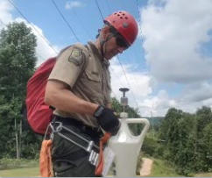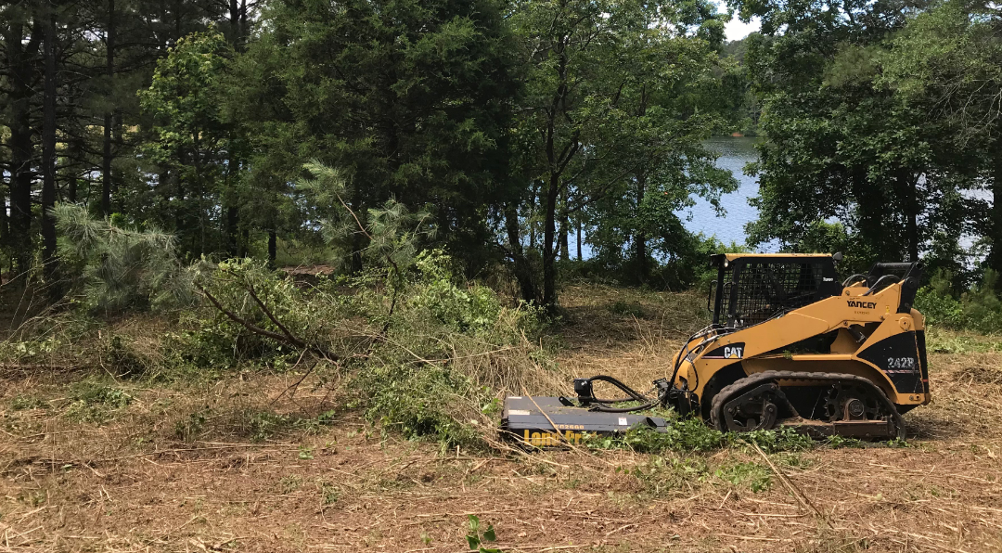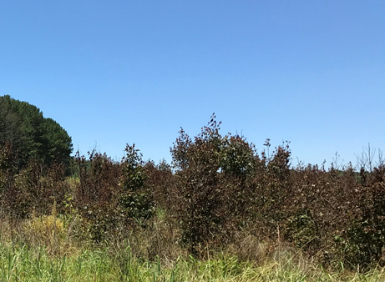

Challenges
- Several sites needing to hire part-time staff, especially housekeeping staff, are not getting as many applications as normal.
- Cottage turnovers are high at some sites and continue to be a challenge.
- Many sites are having trouble getting hosts for the summer. This is typical for this time of year, but is compounded by the abnormally high levels of visitation and staff shortages.
- Bear issues continue at Ft. Mountain and Black Rock with bears not practicing social distancing. These sites are informing the guest about food and trash storage procedures.
- Several visitors at Skidaway complained about limited access to the visitor center because they had to wait to enter, while others mocked the staff wearing masks and made politically oriented comments towards them.
- The bank which services both Wormsloe and Skidaway has limited their access to change, citing a national coin shortage as the reason.
- Ft. Yargo staff assisted a cottage guest who’s 2-year old was locked in a cottage bathroom.
- A cottage guest at Fort McAllister was injured in a boating accident, incident report submitted.
- At Sweetwater Creek a car was broken into on Saturday in the picnic loop. On Sunday evening Douglas County SO responded to a domestic dispute in the bait shop area.
- At Watson Mill Bridge a guest was injured on the sliding rock Saturday. She was taken to Athens Regional Medical Center with a broken ankle and other leg injuries. Madison County EMS assisted with the call.
- At Panola Mountain a guest was injured on the PATH trail about .75 miles from the park's trailhead. The guest was airlifted to the hospital. Rockdale County EMS assisted with the call.

Financial Update:

Past Weekend:
Overall occupancy for all reservables increased 8% this past weekend to 76%. All overnight reservables saw an occupancy increase. Camping increased 10%, reaching 85% occupancy. Yurts were at 99% occupancy, 2% higher than the previous year. Cottage rentals also saw a slight increase going from 86% to 88%.

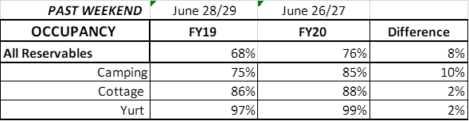

Upcoming Weekend:
For the upcoming weekend, we are already seeing a 5% increase in all reservables at 81% occupancy. Camping is showing a 3% increase, cottages are looking to increase 5% in occupancy to 95%, while yurts are showing a 10% increase to 100% occupancy.

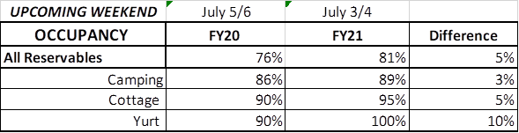

Revenue:
Year to date thru June 28th, park receipts have increased 8% or $2.5 Million over last year. This past week, June 22nd – 28th, there was a 21% or $202,000 increase in overall revenue. This is the 11th week in a row revenue has increased since the COVID situation began.

For overnight accommodations – camping revenue continues to significantly increase. This past week camping improved 70% or $172,000. Cottages also saw a significant revenue increase this past week increasing $110,000 to $362,000 for the week; yurts improved 30% or $4,000.

This past week, ParkPass revenue increased 15% or $18,000 compared to last year.

Golf was up 57% this past week or $19,000.

The revenue continues to significantly improve over last week due to several reasons:
- In early April we changed policy from collecting only a one-night deposit when booking a reservation, to collecting all revenue at the time of booking. This is the reason for the significant increase to camping, cottage and yurt revenue. This will influence future revenue collections and the amount of refunds given.
- Camping occupancy has improved over the previous year for the 11th weekend in a row. And cottage and yurt occupancy are similar to where they were in previous years or have slight improvements each week.
- And again, the number of cancellations is starting to significantly slow down. Although we do need to keep in mind, that for future refunds, we will be refunding the revenue for the entire stay, rather than just a one-night deposit.

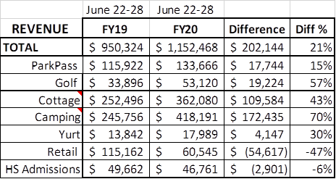

Cancellations/Refunds:
Through this morning, there were 35,000 reservation cancellations, including $3.0 Million in actual refunds and a loss of future revenue of $13.6 Million. This is 2,000 more than last Monday, which was at 33,000 cancellations. The significant drop in the number of cancellations continues, as initially there were 4,000 – 5,000 a week, although there continues to be a higher number of cancellations than the previous year. Last year during the same week there were 800 cancellations, thus we had 1,200 more cancellations this past week than last year during the same time period. Last year during March thru YTD, there were 13,600 cancellations, including $706,000 in actual refunds and a loss of future revenue of $3.3 Million.
So, total cancellations have increased over 21,400 or 157% and the amount of refunds have increased $2.3 Million.

